Rendering in Maya and finishing in After Effects

MAYA

Set render settings

Window->Rendering Editors->Render settings

Image Format: IFF
Frame/Animation ext: name.#.ext
Frame Padding: 3 (or however many digits the maximum frame number will have)

Set start and end frame

Image size: HD 720 Preset (1280x720)

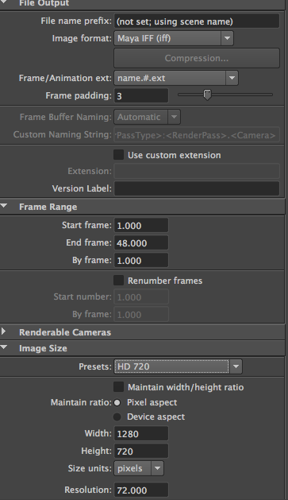

Render

Go to Rendering Menu Set

Render->Batch Render

Progress is in the script window

Frames are saved to the maya project folder:

Documents/maya/projects/default/images/frame001.iff etc

AFTER EFFECTS

Create a new composition

Size: 1280x720
Frame rate: 24
Set the duration

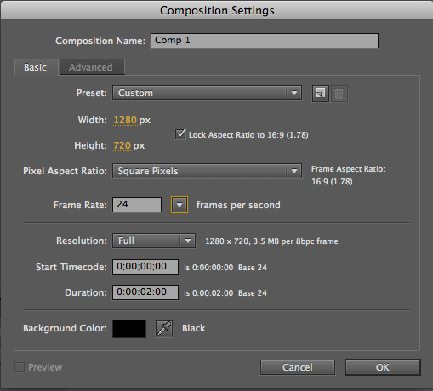

Import footage

File->Import->File

Select the first image in the IFF sequence, and it will import the whole sequence as a clip.

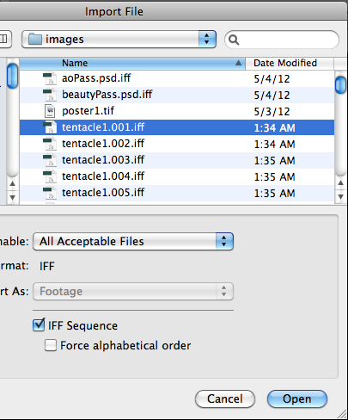

Set framerate

Select the clip the project window
File->Interpret Footage->Main
Set framerate to 24

Can also set looping here

Put clip in timeline

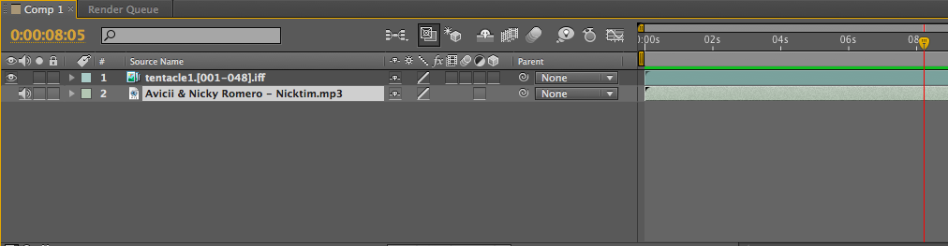

Add audio

If Aftereffects doesn’t like an MP3, convert it to WAV in Audacity or Audition first. Also probably best to edit the clip to get the excerpt you want before importing.

Previewing

Composition->Preview->RAM Preview

Or, in the Preview window: the regular play button just plays the video. The play button on the right is the RAM preview button and plays the audio too.

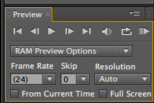

Render

Composition->Add to Render Queue

Change Output Module from Lossless to H264.

Click H264 and check the box for Audio Output

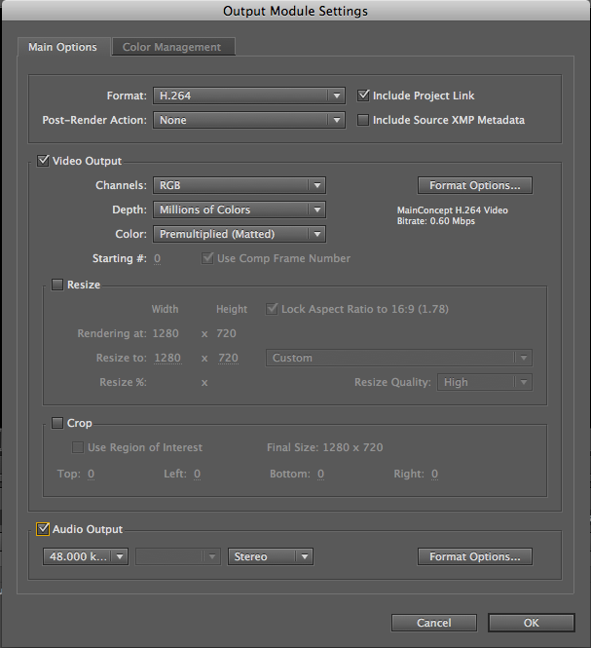

Change Output to… to the file you want to render to (e.g. Tentacles.mp4)

Click Render

To render again, select the item in the Render Queue, R-Click, Duplicate.

